**NAME: SURAJ**

**DATE:02/03/2023**

**TASK - 2**

**1)perform ip address spoofing:**

IP address spoofing is a technique used by attackers to manipulate the source address of a network packet to conceal their identity or impersonate another system.

$ ifconfig

$ ifconfig eth0 192.168.233.128

$ ifconfig

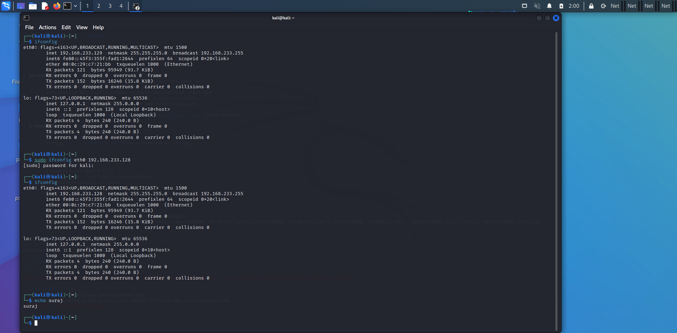

**2) Perform mac address spoofing:**

MAC spoofing is a technique for changing a factory-assigned Media Access Control (MAC) address of a network interface on a networked device. The MAC address that is hard-coded on a network interface controller (NIC) cannot be changed. However, many drivers allow the MAC address to be changed

$ macchanger -s eth0

$ macchanger -r eth0

$ ifconfig

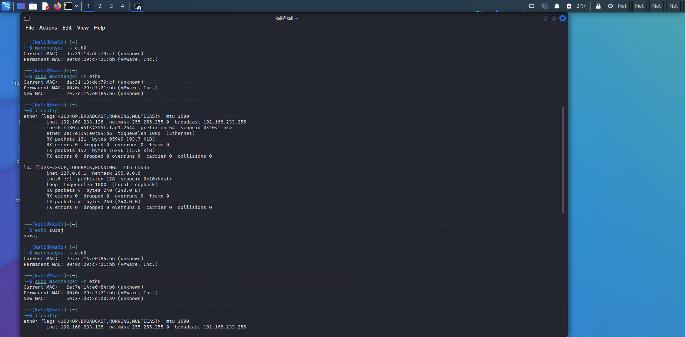

**3) Any 5 whatweb commands:**

This tool can identify and recognize all the web technologies available on the target website This tool can identify technologies used by websites such as blogging content ,management system ,all javascript libraries whatever contains more than 180 modules

Basic scanning:

The most basic command to scan a website with WhatWeb is

$ whatweb mitkundapura.com

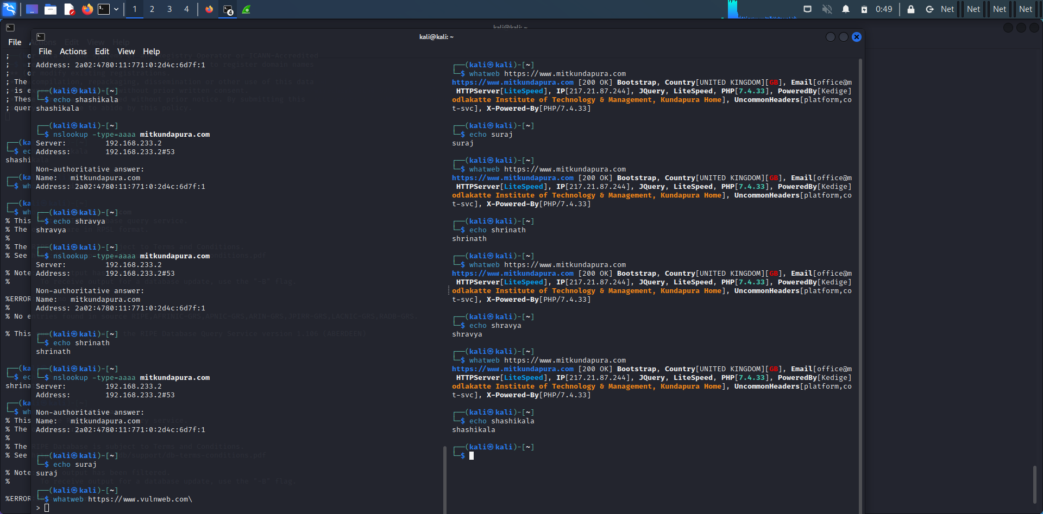

Verbose scanning:

If you want more detailed information about the website, you can use the verbose flag (-v):

$ whatweb -v mitkundapura.com

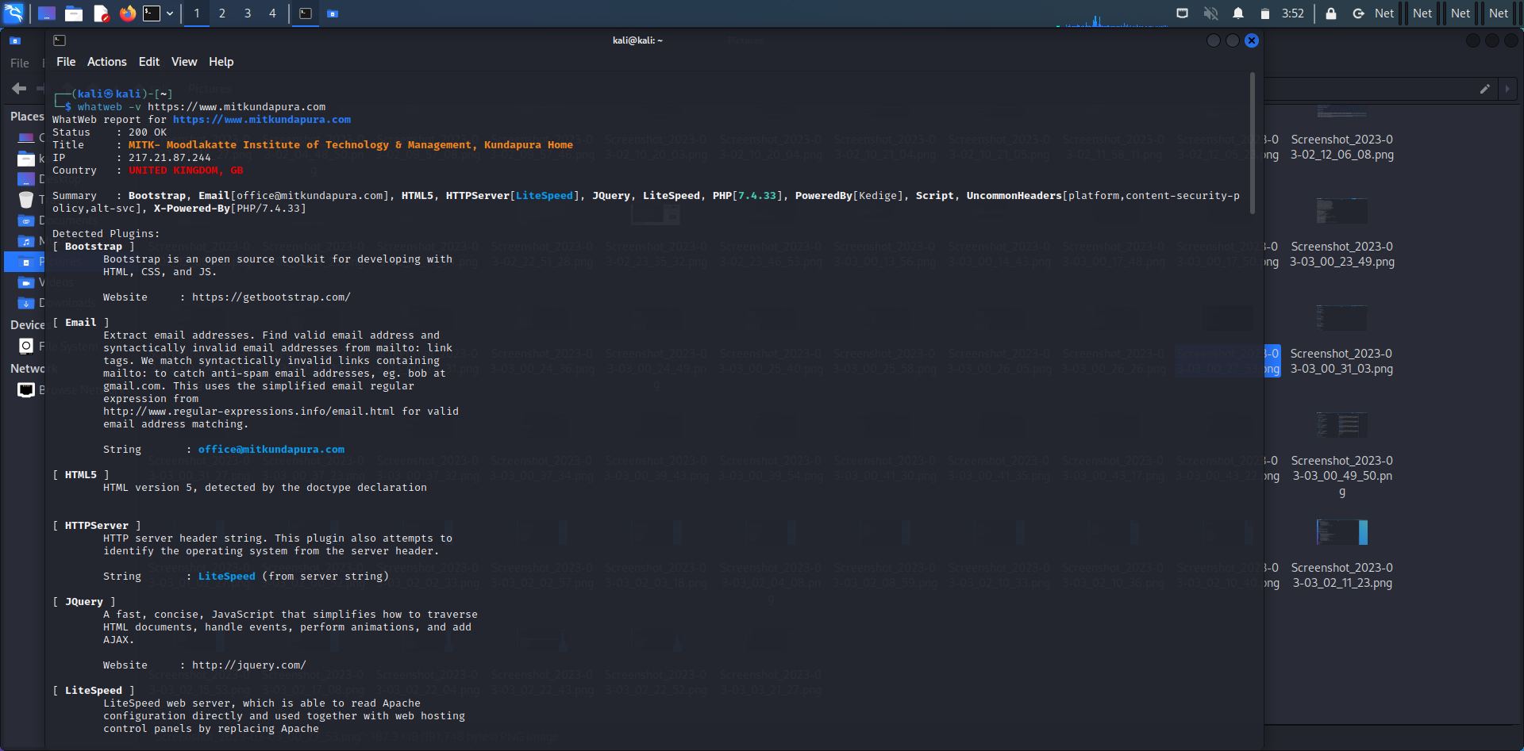

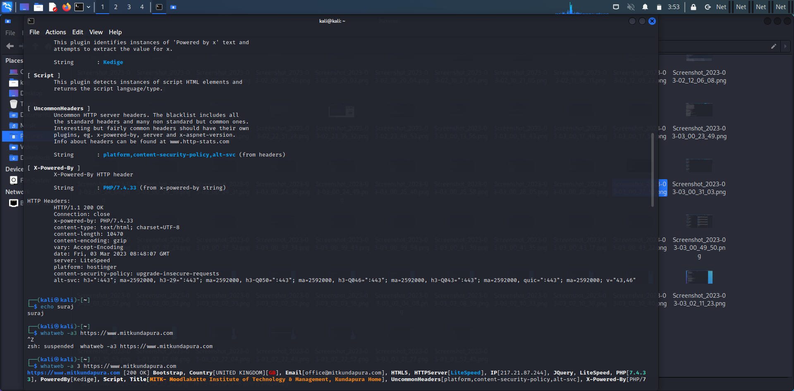

$whatweb -a 3 <https://www.mitkundapura.com>

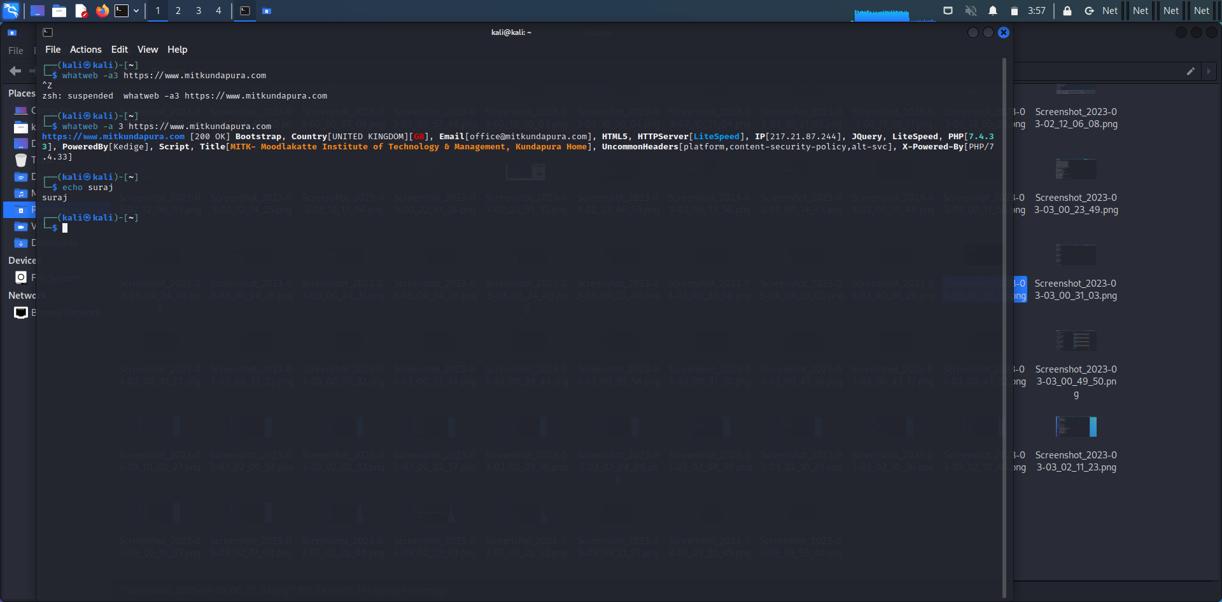

$whatweb –max-redirect 2 https://www.mitkundapura.com

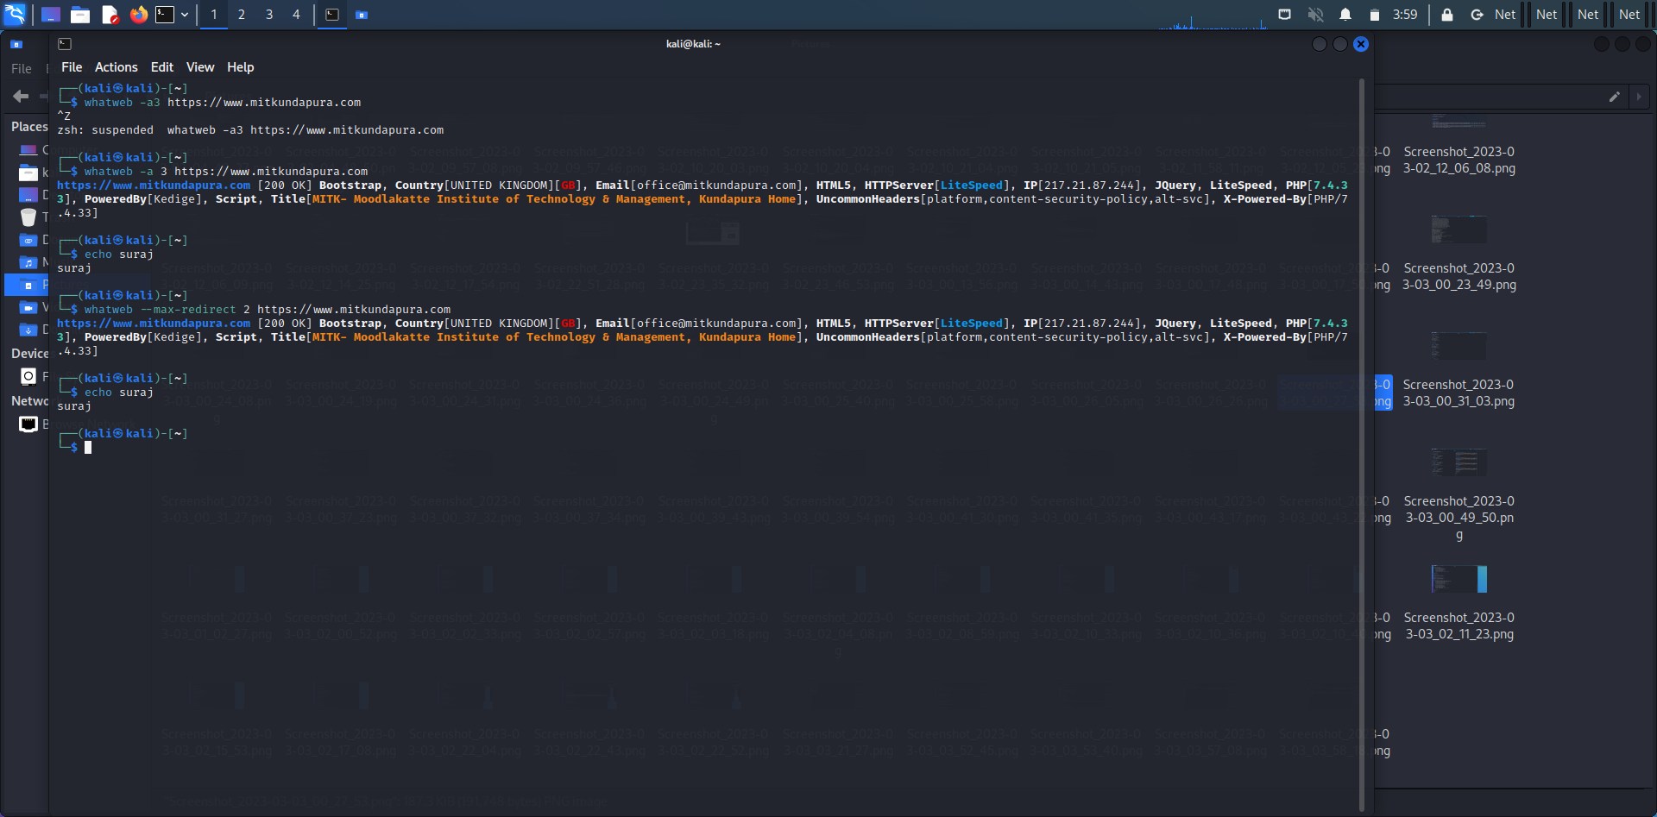

$whatweb -v -3 https://www.mitkundapura.com

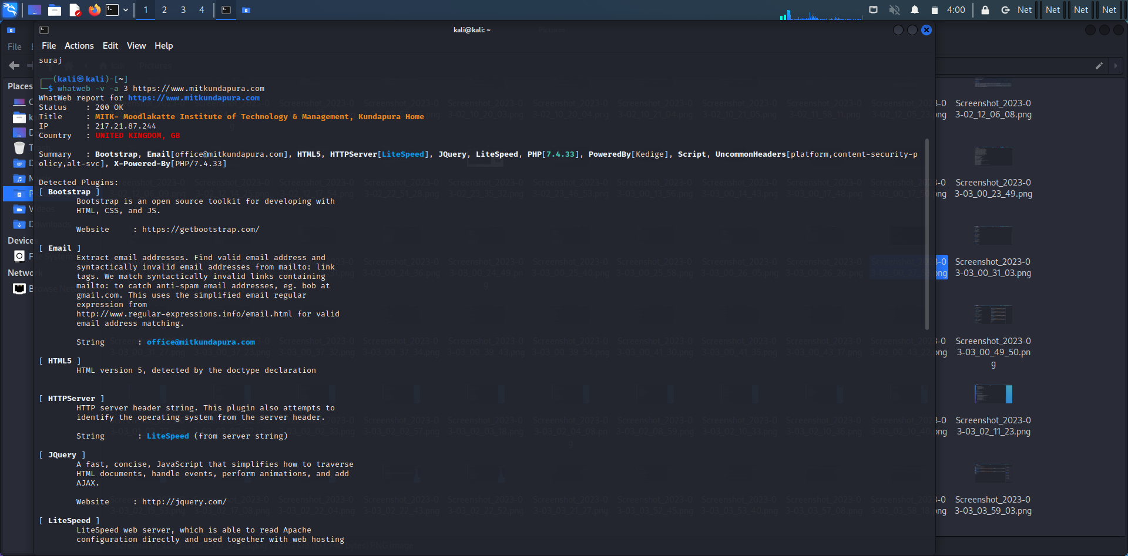

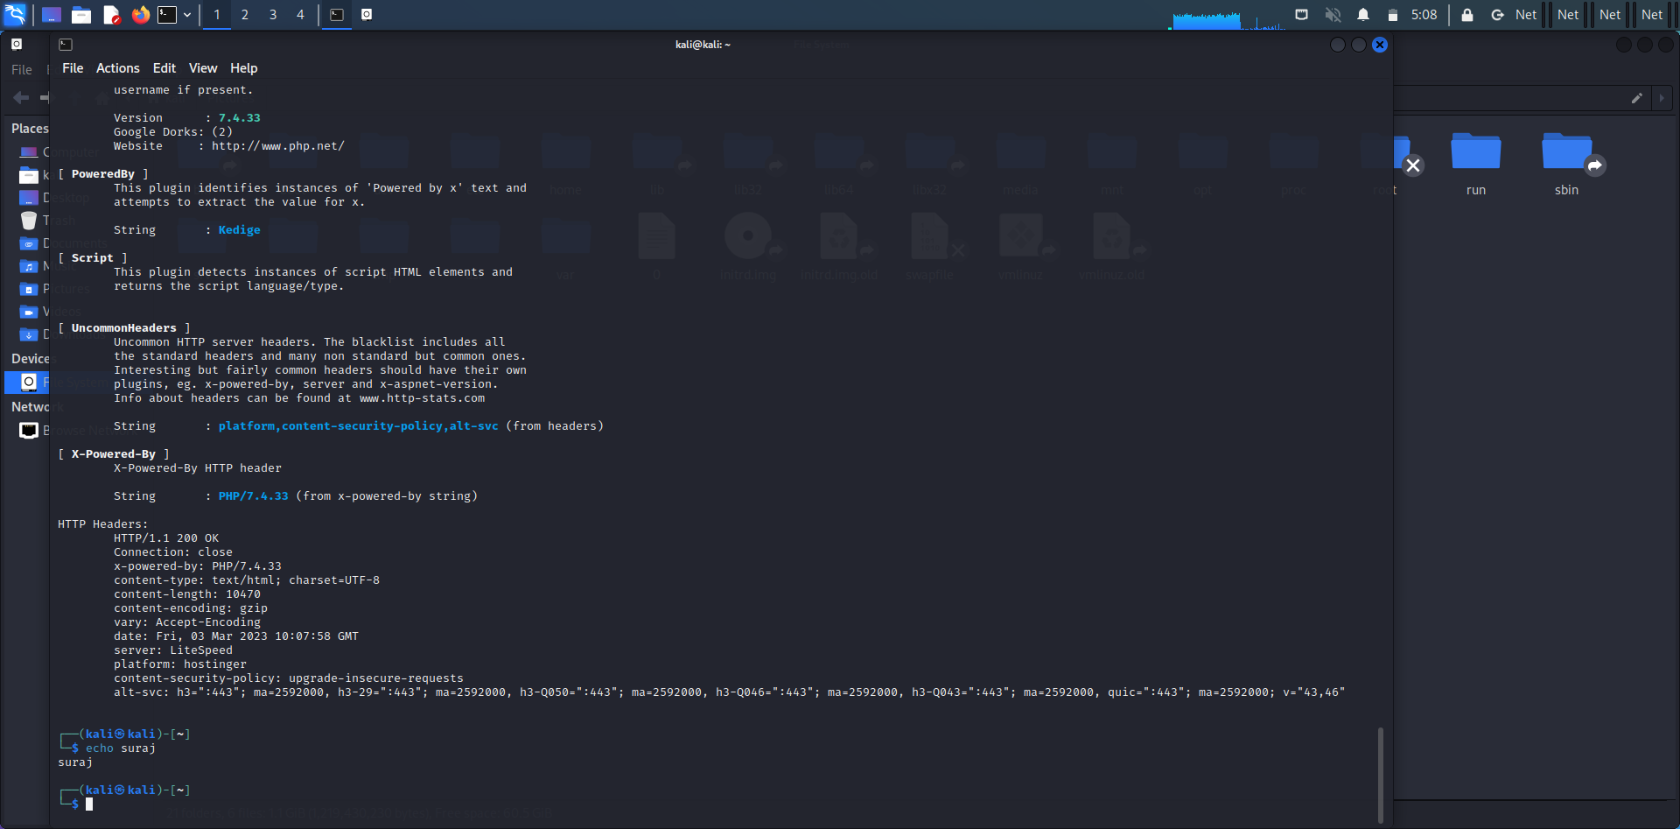

**4)Any 5 nslookup commands:**

This is useful comment for getting information from the DNS server It is a network administration tool for querying the domain name system to obtain domain name or IP address mapping or any other specific DNS record. It is also used to troubleshoot DNS related problems.

**$ nslookup google.com:**

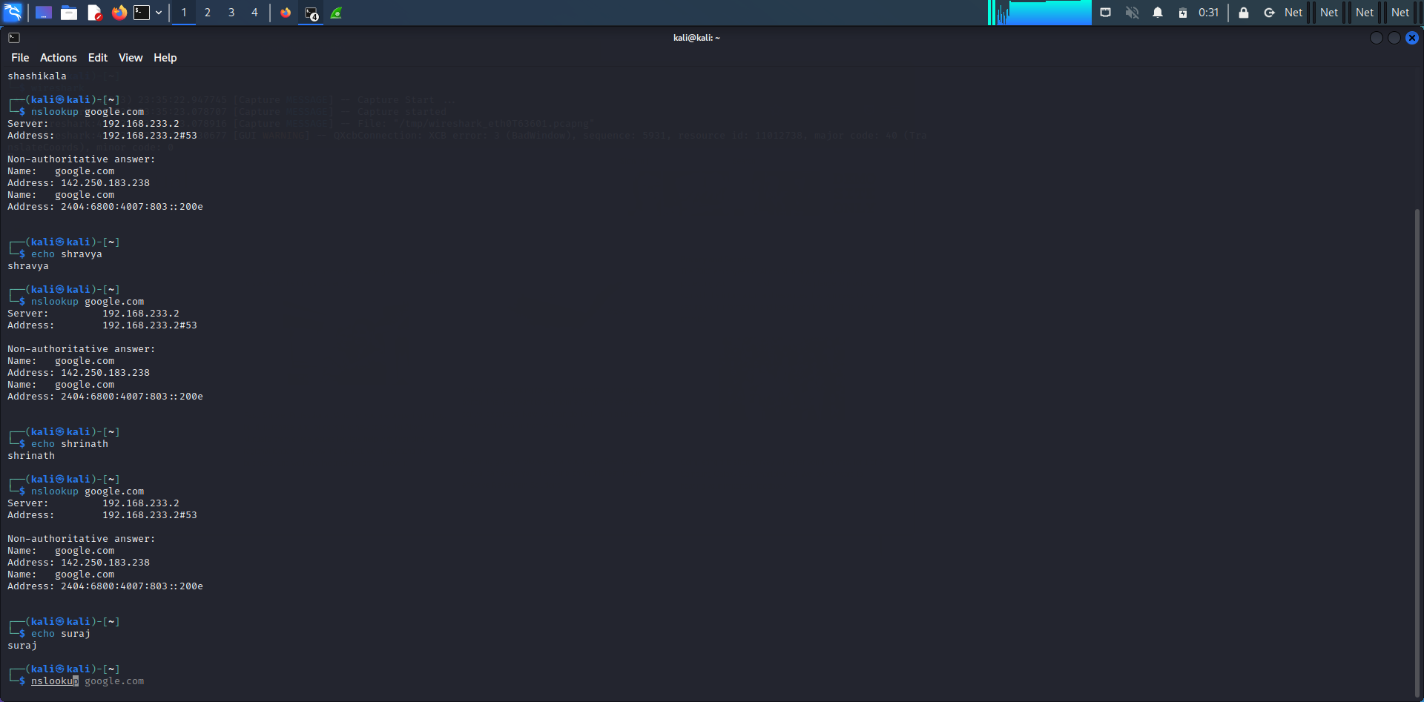

**$ nslookup -type=mx mitkundapura.com**

This command will perform a DNS lookup for the mail exchange (MX) records associated with the domain name “example.com”.

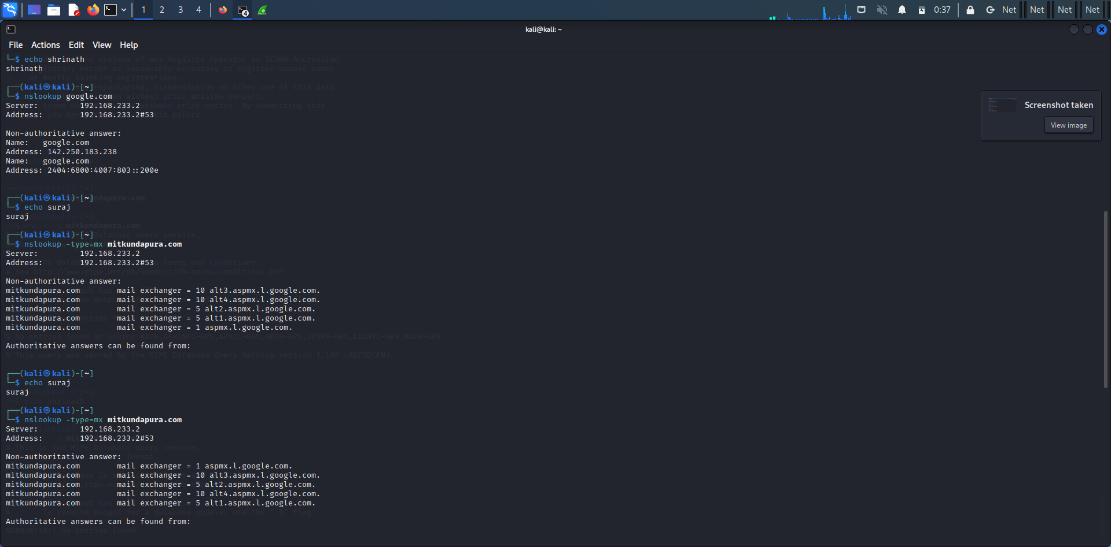

**$ nslookup -type=ns mitkundapura.com**

This command will perform a DNS lookup for the name server (NS) records associated with the domain name “example.com”.

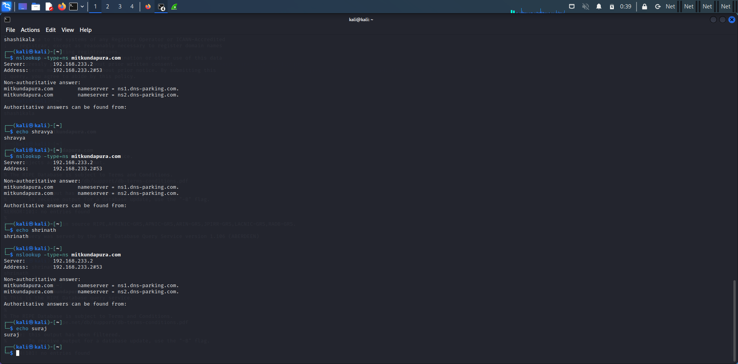

**$ nslookup -type=a mitkundapura.com**

This command will perform a DNS lookup for the IPv4 address associated with the subdomain www.example.com.

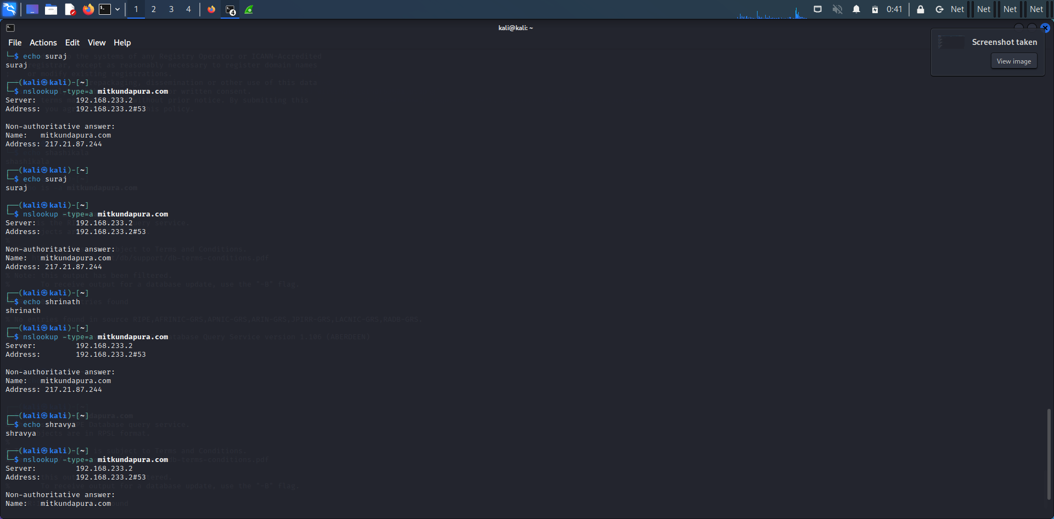

**$ nslookup -type=aaaa mitkundapura.com**

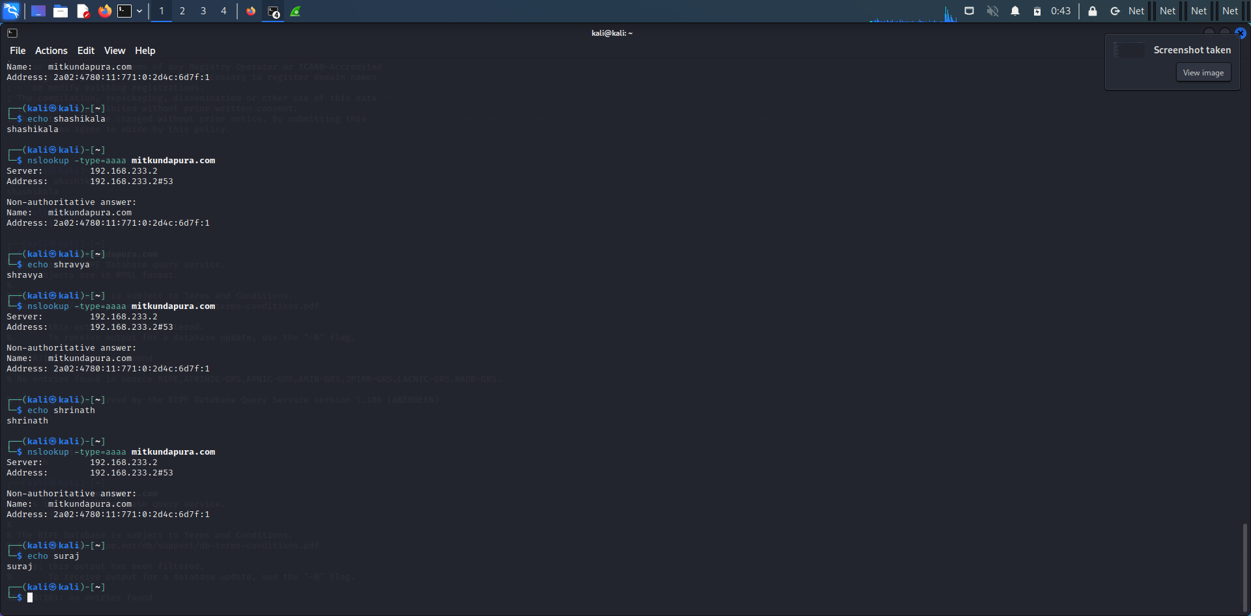

**5) whois command:**

The WHOIS command is a network administration utility used to obtain information about a domain name, IP address or an autonomous system number (ASN) on the Internet. It allows you to look up information about the registered owner of a domain name, including the domain's registrar, date of registration, expiration date, and contact details.

**Commands:**

$ whois mitkundapura.com

This command will display information about the domain name, such as the name of the registrant, the name servers, and the date of registration

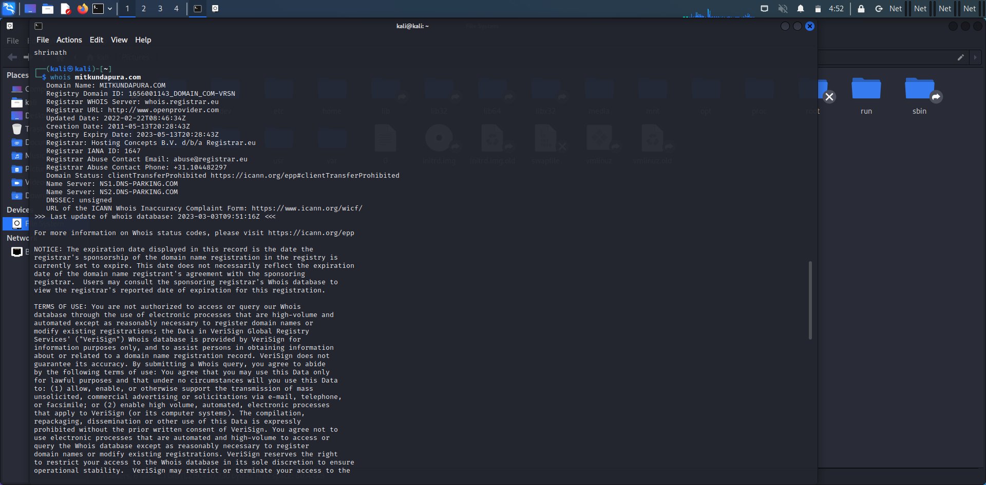

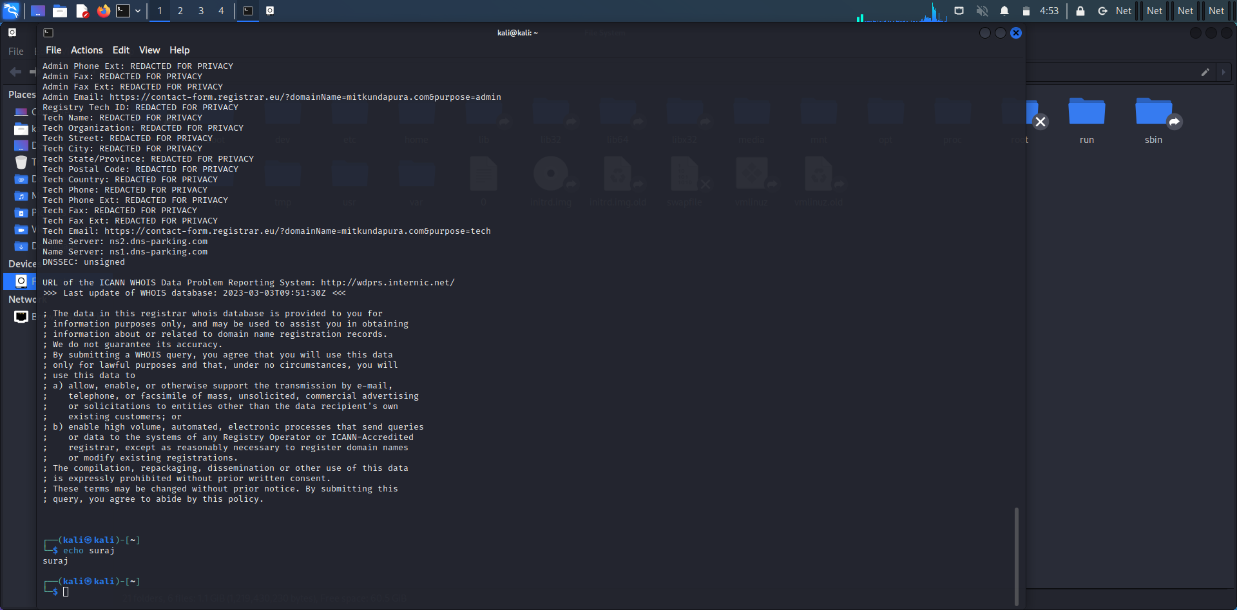

**6) Find data packets using wireshark:**

Wireshark is a network protocol analyzer, or an application that captures packets from a network connection, such as from your computer to your home office or the internet. Packet is the name given to a discrete unit of data in a typical Ethernet network. Wireshark is the most often-used packet sniffer in the world.

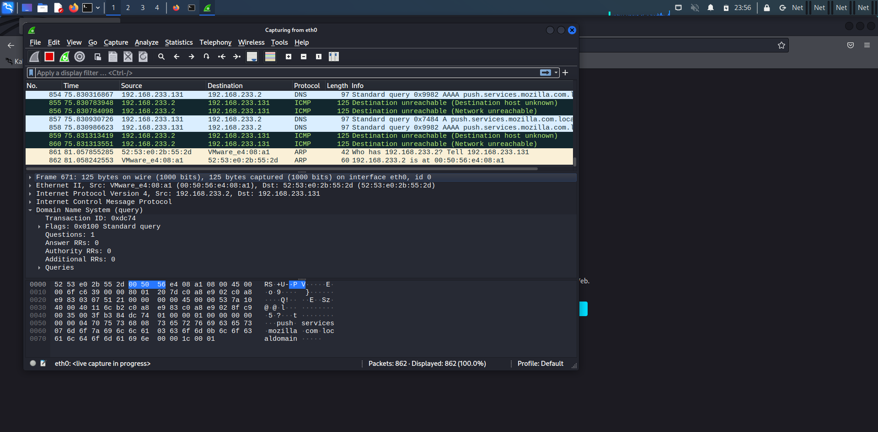

**7) Any 5 netdiscover command:**

Netdiscover is a network scanning tool used for discovering hosts and gathering information about them on a local network. Here are some of the basic commands:

$ netdiscover -i eth0

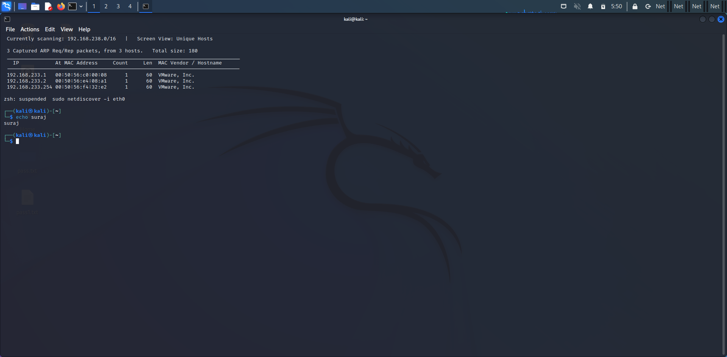

$ netdiscover -i eth0 -f

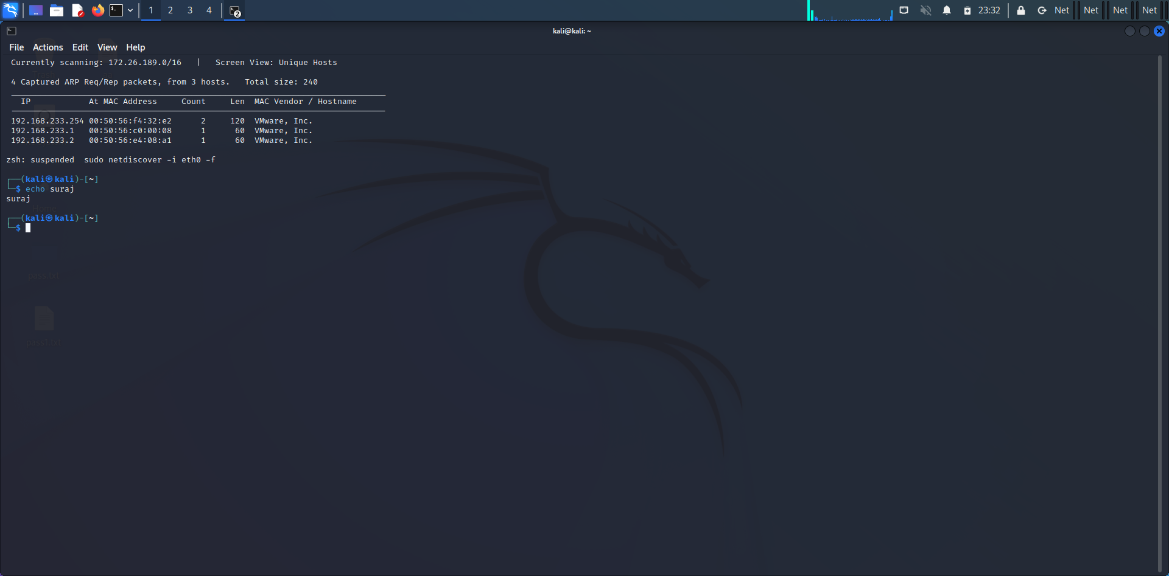

$ netdiscover -p

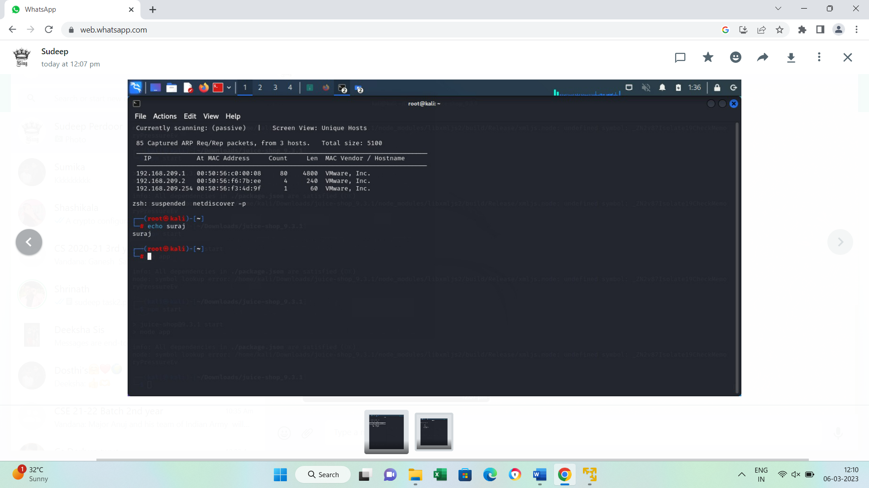

$ netdiscover –s 0.5

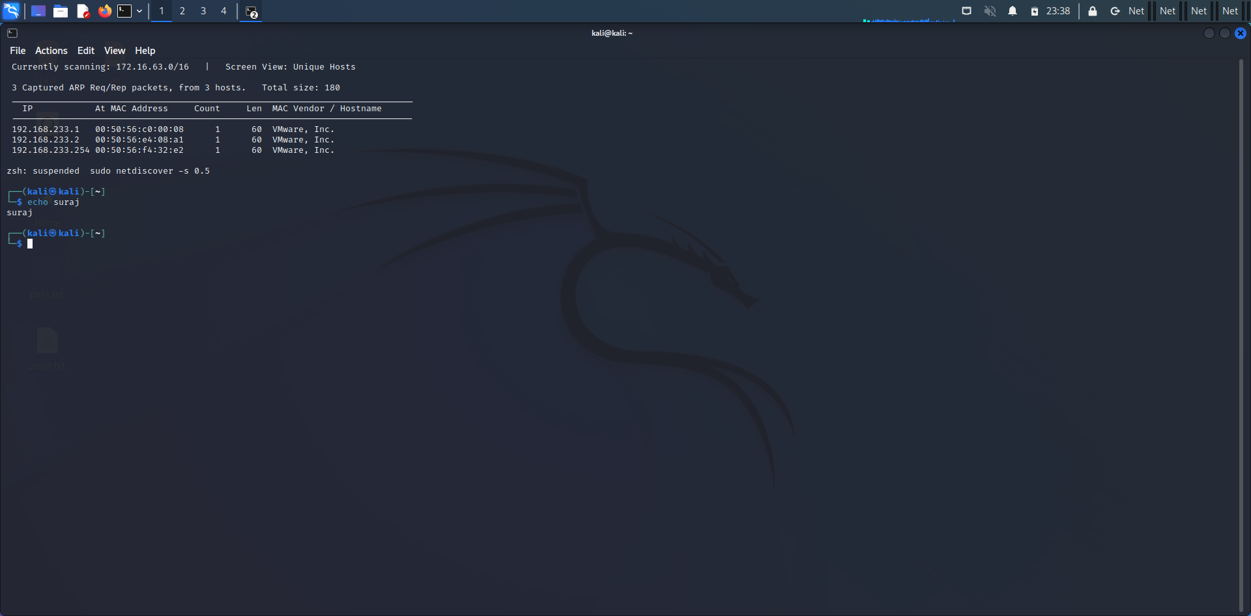

$ netdiscover -r 192.168.0.15

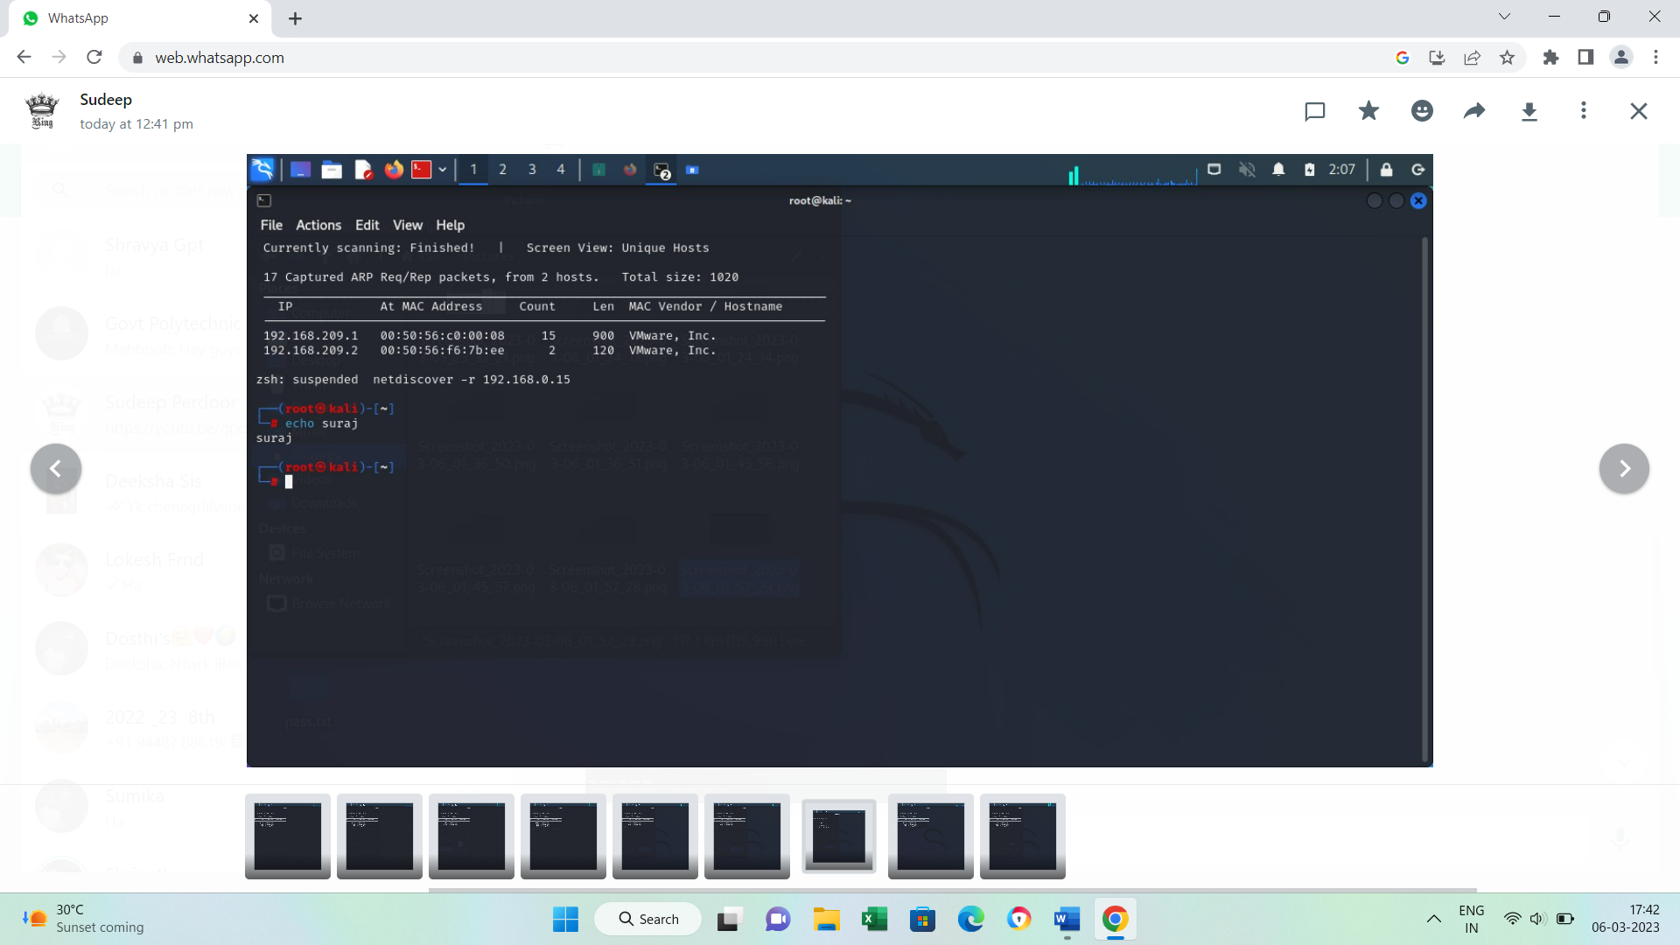

**8) CryptoConfiguration flaw :**

A crypto configuration flaw refers to a security vulnerability that occurs due to improper configuration of cryptographic settings in a system or application. Cryptography is the science of using mathematical algorithms to protect data from unauthorized access or modification, and it is an essential component of modern computer security.

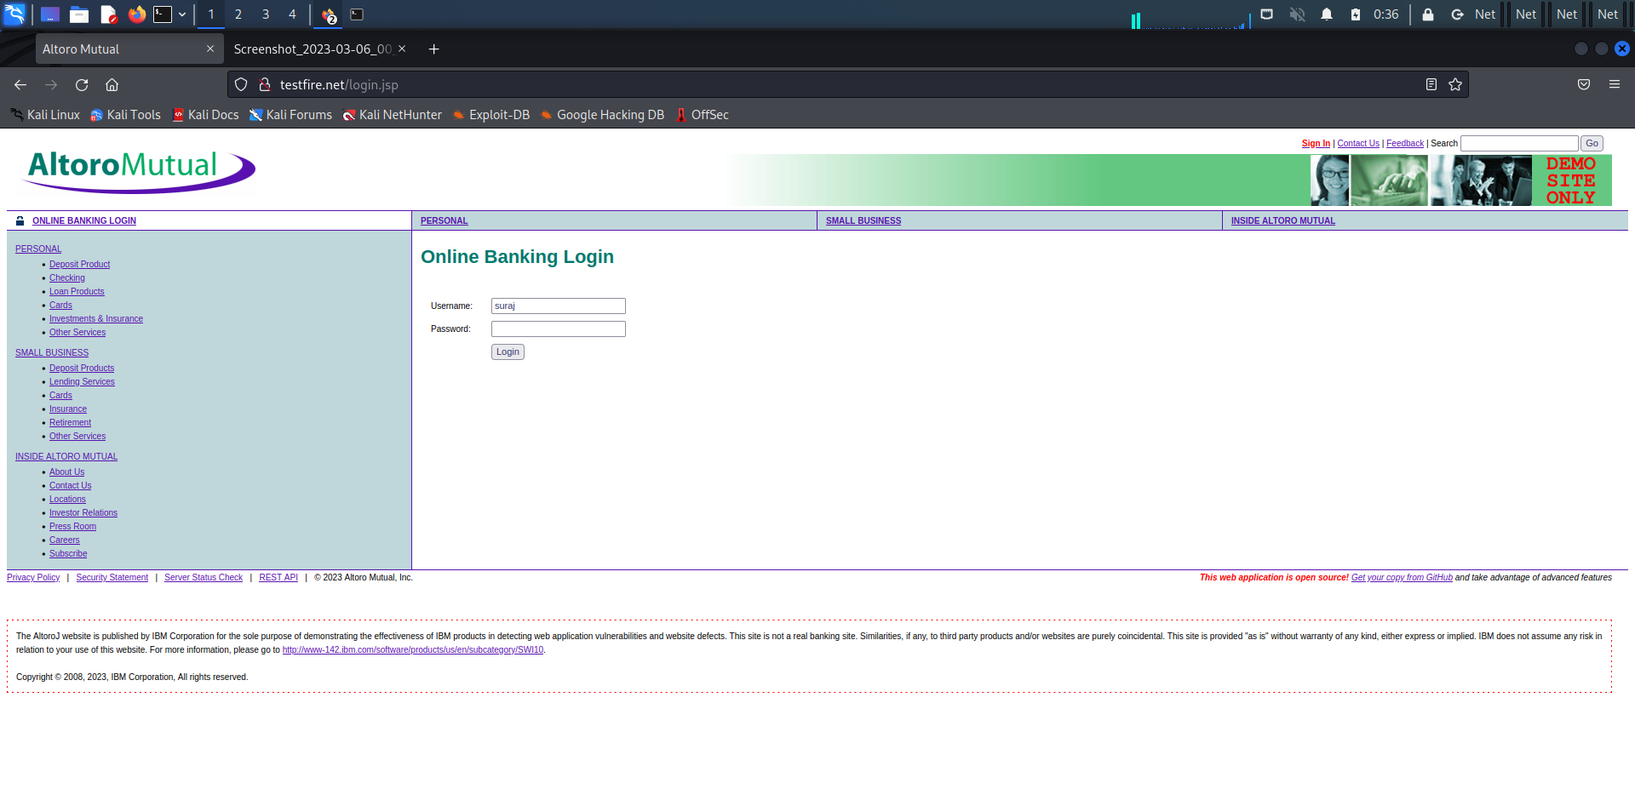

**9) Nikto commands**:

Nikto is a free software command-line vulnerability scanner that scans webservers for dangerous files/CGIs, outdated server software and other problems. It performs generic and server type specific checks. It also captures and prints any cookies received.

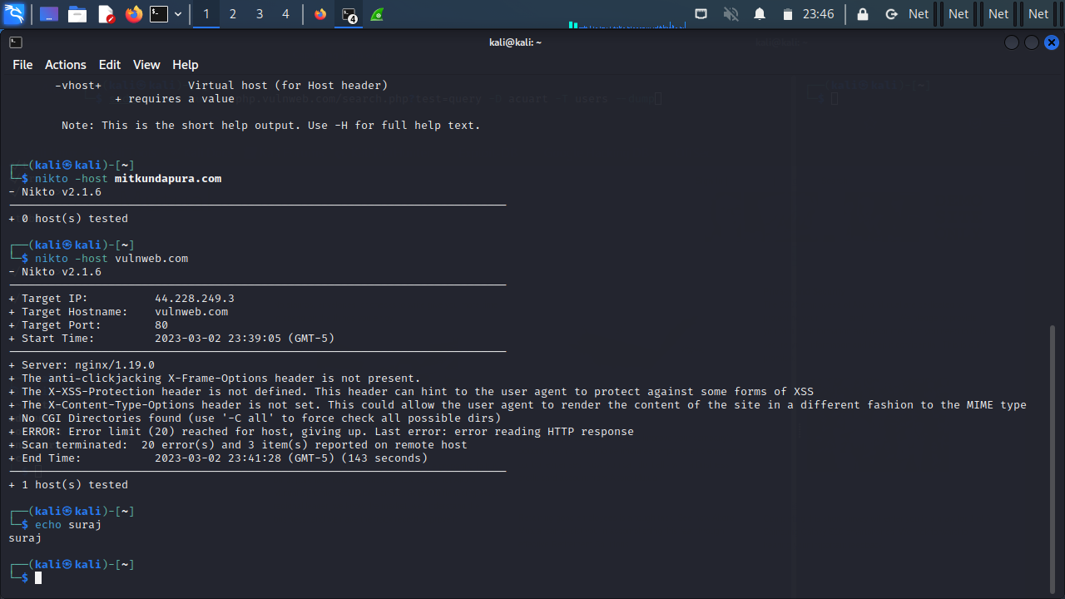

**10) Find xml pages in website using dirbuster:**

DirBuster is a multithreaded java application designed to brute force directories and files names on web/application servers. Often is the case now of what looks like a web server in a state of default installation is actually not, and has pages and applications hidden within

